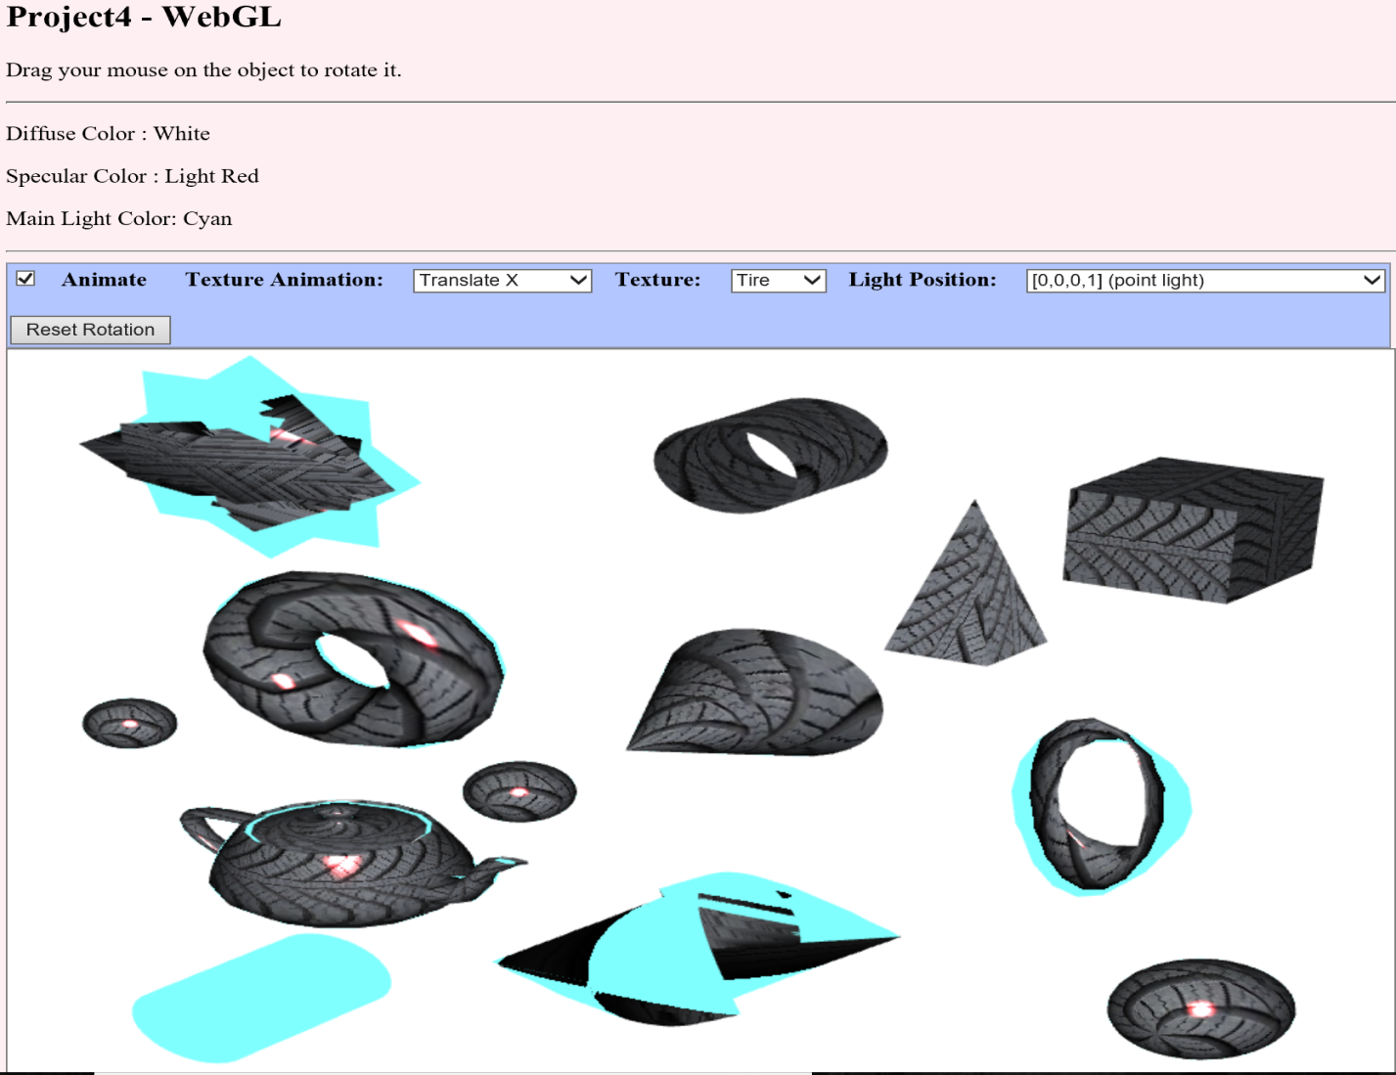

Figure 1: Output of Project 4

# **WebGL 3D Project -Project 4**

Golsa Emdadi

CMSC 405 7982 Computer Graphics (2178)

Due December 17, 2017 11:59 PM

# **User’s Guide**

The project 4 needs to create a unique 3D animated scene composed of WebGL graphic components. The scene should include animation, lighting, textures, frame buffers and multiple objects.

**Project 4 requirements**

Using WebGL create a unique 3D animated scene. The scene has the following specifications:

1. Size: minimum 640x480
2. Includes at least 10 different objects.
3. Uses multiple lighting effects on different materials
4. Uses multiple textures
5. Includes radio buttons, slider bars or other widgets to turn on or off certain components of the animation.
6. Uses frame buffers to organize the memory resources that are needed to render the scene.

# **Description**

1. Open project 4 folder, click and run project4.html with Firefox, Internet Explorer, or Microsoft Edge. The project 4 has “*SORRY, can't access texture image. Note that some browsers can't use a texture from a local disk*” error when runs with Chrome browser.
2. Thirteen 3D objects or shapes are displayed (4 torus shapes, 2 cylinders, 3 spheres, 1 pyramid, 1 cone, 1cube, and 1 teapot shapes). The canvas has width=950 and height=600. The frame buffers are used to organize the memory resources that are needed to render the scene.

# **Shapes:**

basic-object-models-IFS.js is modified to create 13 objects or shapes. Also, all objects have image texture and cyan color, which are combined together.

1. Cube: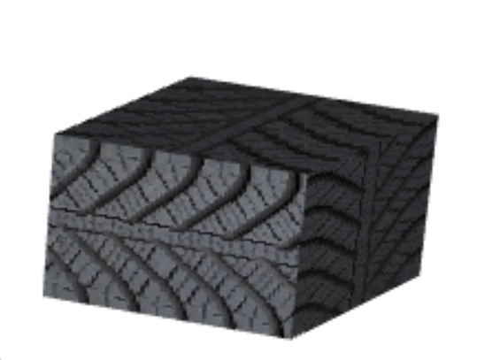

Figure 2: Cube

The position of the cube is changed (it translated from the origin to top-right of the screen, and scaled smaller than original one)

1. Pyramid: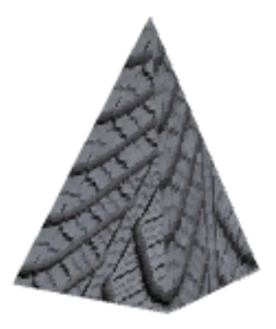

Figure 3: Pyramid

The pyramid is translated to the right-top of the screen with smaller size than original one.

1. Cone: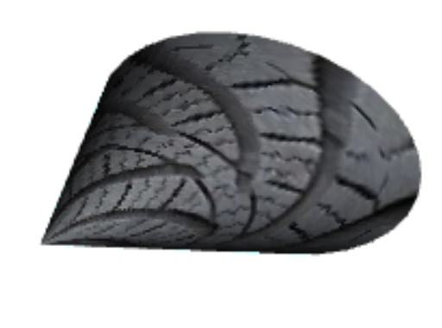

Figure 4: Cone

The cone is scaled smaller than original one in texture-transform.html and basic-specular-lighting.html files. The cone is the z-axis, and the center is at (0,0,0).

1. Two cylinders: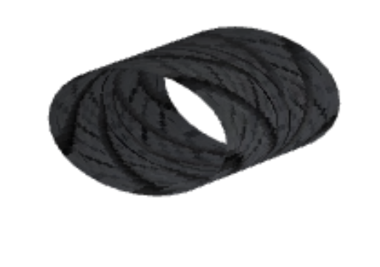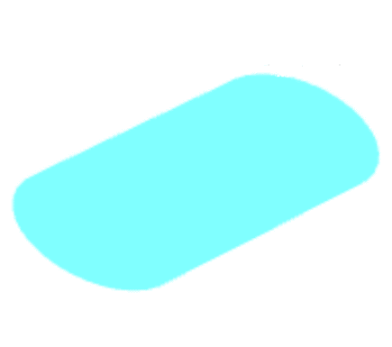

Figure 5: Two cylinders

The cylinder was on the z-axis, and the center was at (0,0,0) on original version in texture-transform.html and basic-specular-lighting.html files. The modified black version does not have lids on top and bottom, translated to top-middle of the screen, and scaled smaller than original one. Also, second blue cylinder is translated to the left-bottom of the screen and scaled with more height than black cylinder (texture of blue cylinder is visible in [0,0,-10,1] light position).

1. Star-Torus: 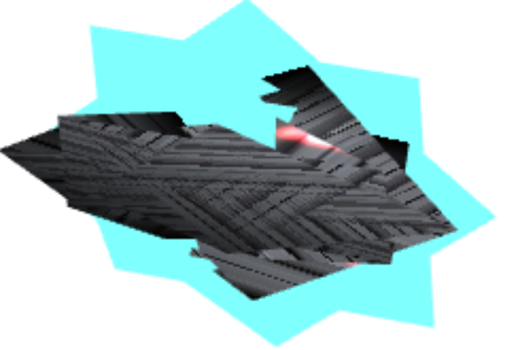

Figure 6: Star-Torus

Original uvTorus function of basic-object-models-IFS.js is modified to create a star shape of torus with cyan color and image texture.The star position is in top-left of the screen (canvas).

1. Torus: 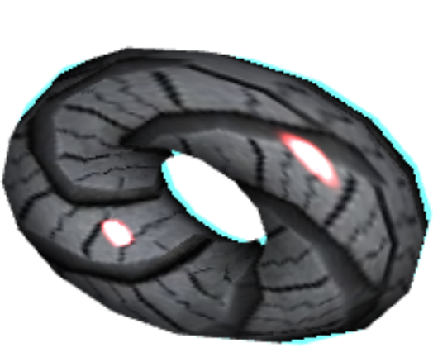

Figure 7: Torus

The original uvTorus function is modified. This torus is translated to left-middle of the screen and smaller than original version.

1. Second type of torus: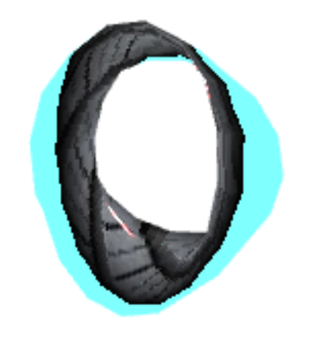

Figure 8: Torus2

It is translated to the right-middle of the screen and smaller than original one with cyan color and image texture.

1. Bow-torus: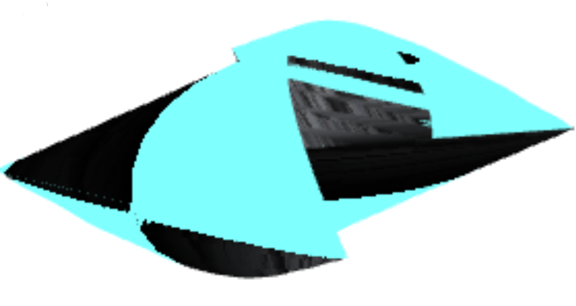

Figure 9: Bow-Torus

The original uvTorus function is modified to create a shape similar to a bow shape. It is translated to the middle-bottom of the screen to create bow shape with cyan color and image texture.

1. Teapot: 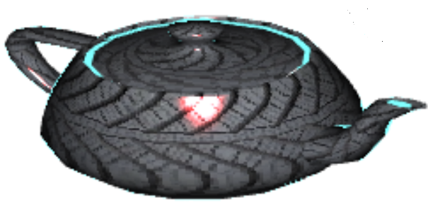

Figure 10: Teapot

teapot-model-IFS.js file is modified to create a teapot model (translated to the left-bottom of the screen and scaled to a size that matches other objects).

1. Three spheres with different sizes and positions:

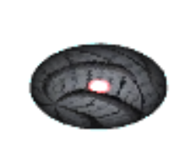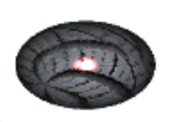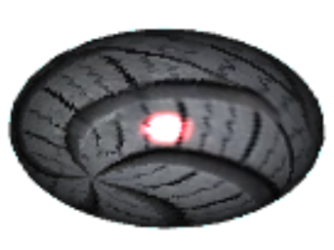

Figure 11: Three spheres

Biggest sphere is translated to the right-bottom of the screen and its size is changed. Second one with medium size is translated to the middle of the screen and its size is changed. Smallest one is translated to the left-middle of the screen and its size is changed.

1. The user can drag her/his mouse on the objects to rotate them (Figure 12 and Figure 13).

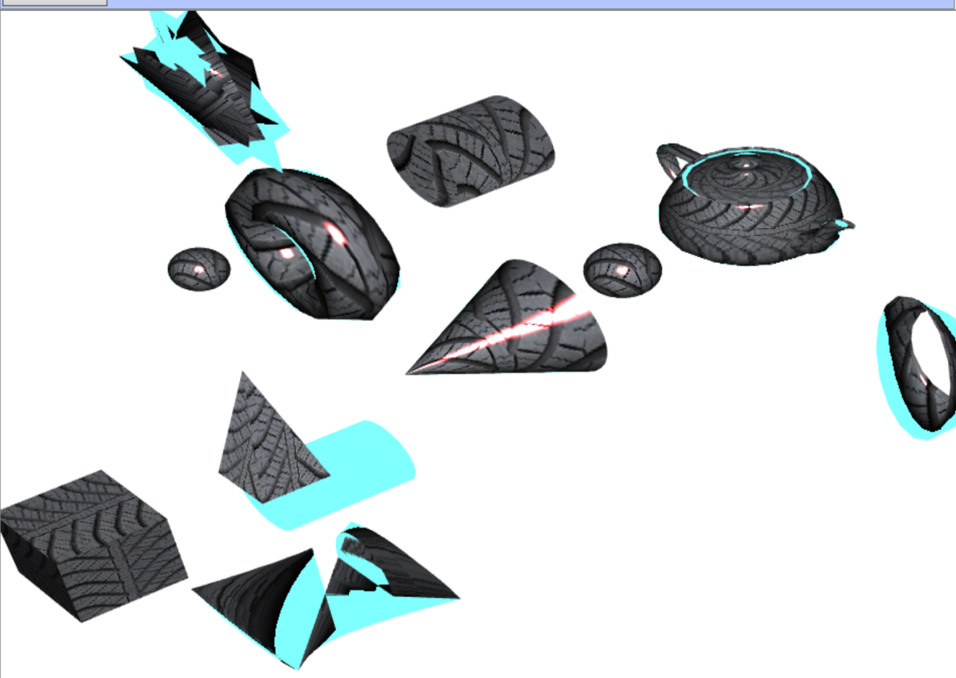

Figure 12: Rotation of objects by the mouse

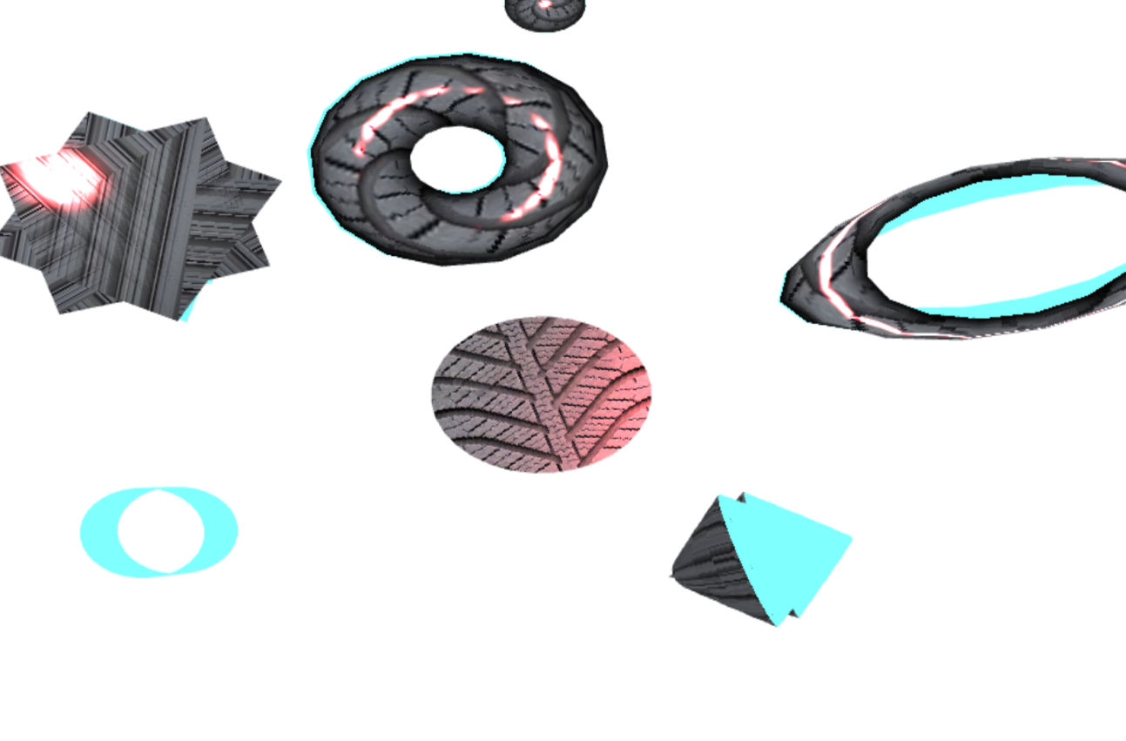

Figure 13: Rotation of objects by the mouse

Note: Some objects may be not displayed inside the canvas when they are rotated in some positions by the mouse.

1. The user can change texture of objects by using of texture combo box (Tire, Fabric, Marble, Wood, and Stone are categories of textures, which their images are in textures folder inside of the project 4 folder).

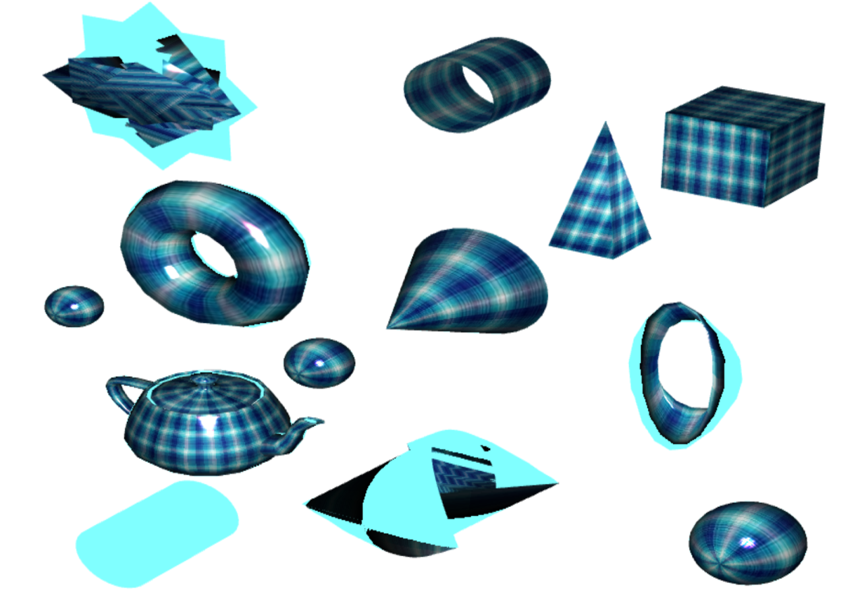

Figure 14: Objects with fabric texture

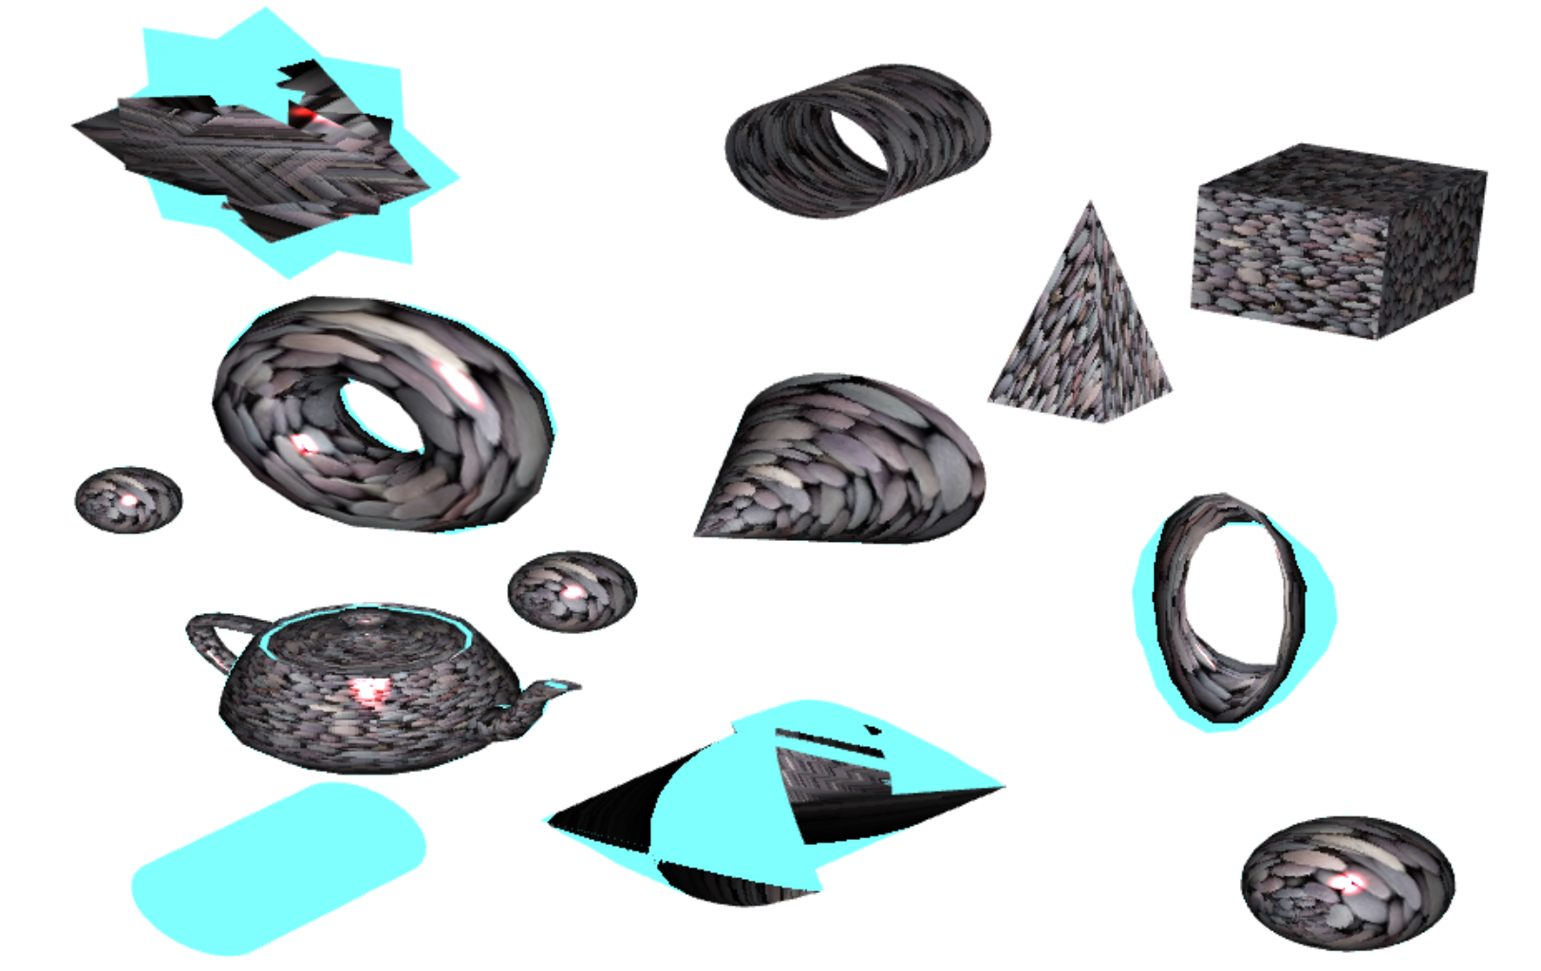

Figure 15: Objects with stone texture

1. The user can change texture animation type of objects by using of Texture Animation combo box. There are translate x, translate y, translate both of x & y, scale x, scale y, scale x & y, rotate, and rotate centered types to change textures or images animations on objects.

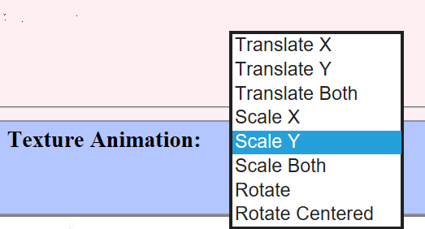

Figure 16: Texture Animation Combo box

1. The user can change light position:

Default light setting is: 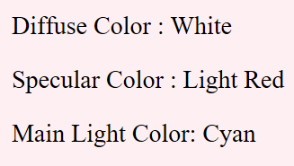

Figure 17: Default light setting

* 1. [0,0,0,1] (point light): It creates point lights with red color on objects. For example, spheres, torus and teapot objects have red point light on their textures (Figure 18).

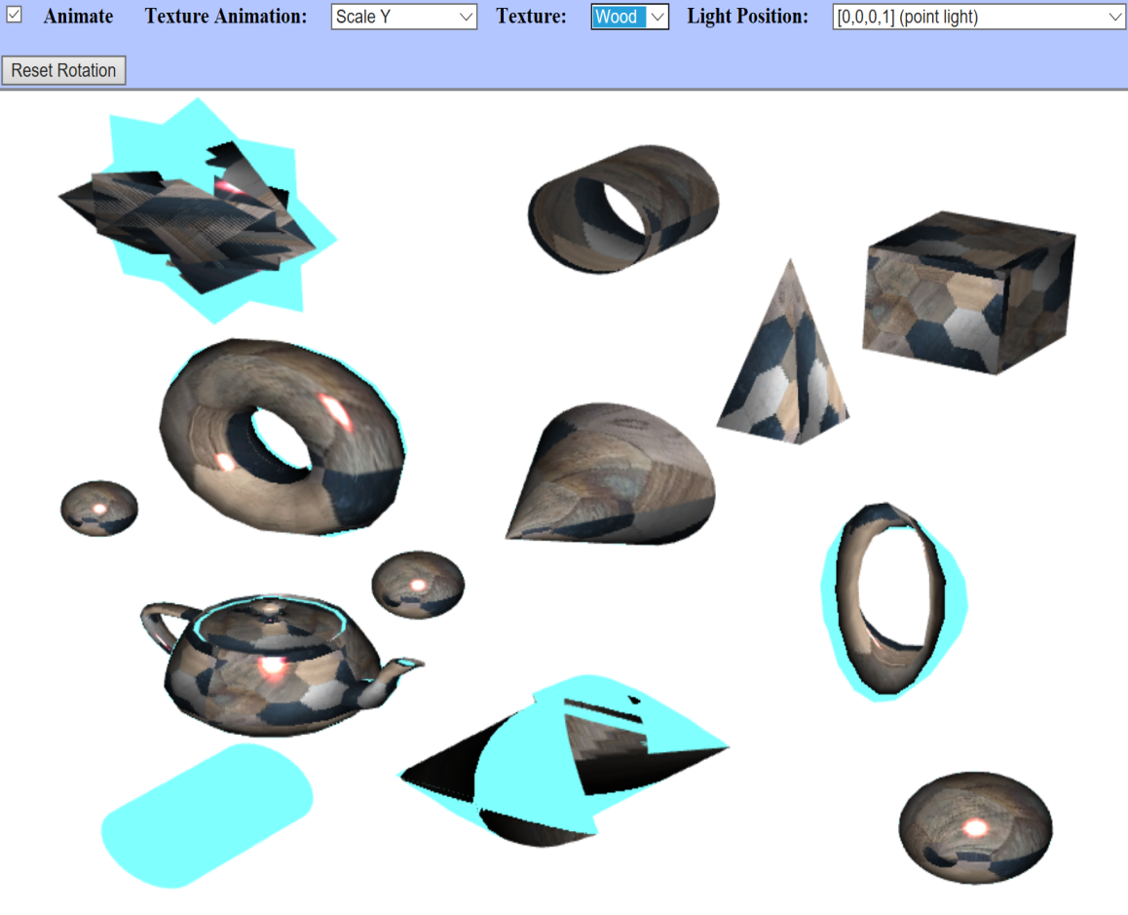

Figure 18: Red point light with wood texture and light position = (0, 0, 0, 1)

* 1. [0,0,0,0] (No light on screen): It removes light effects (all objects are displayed with black color)

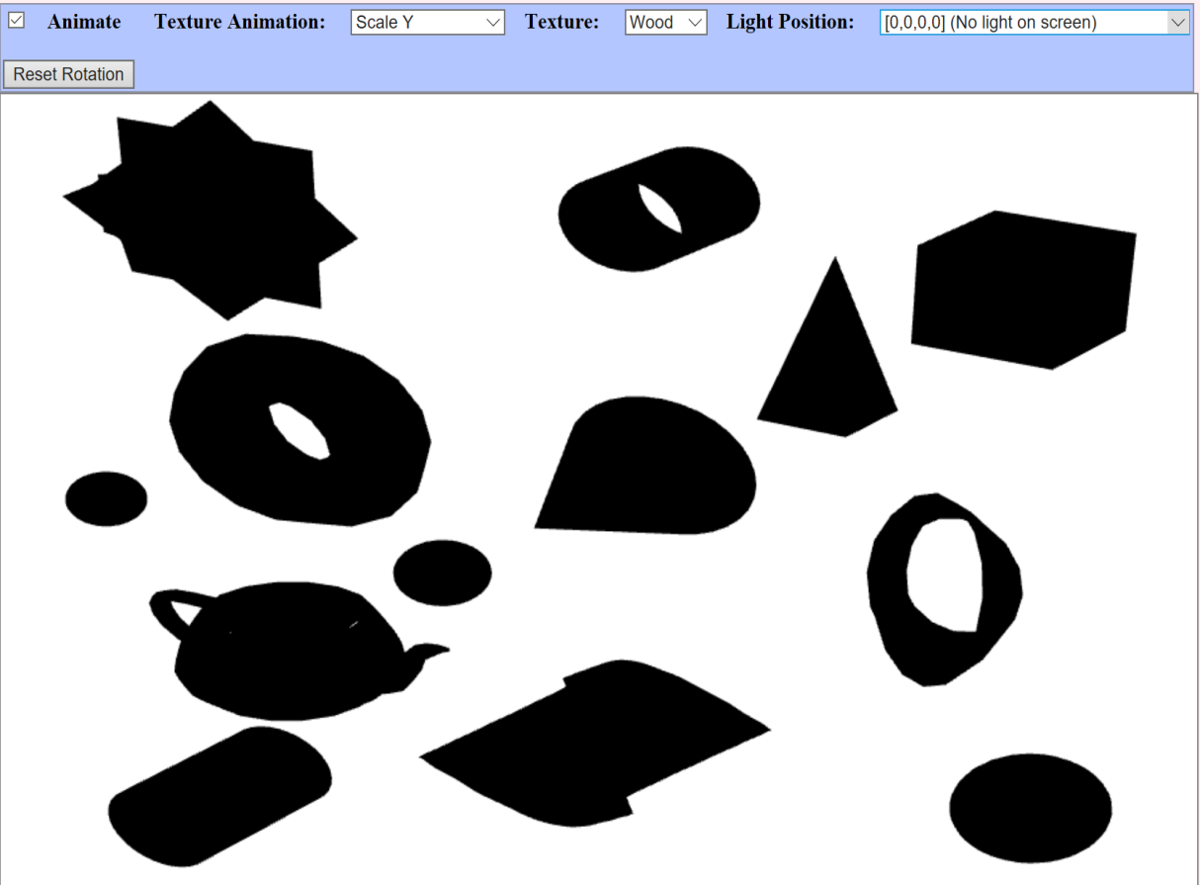

Figure 19: Light position = (0, 0, 0, 0)

* 1. [0,1,0,0] (Directional, from above): Direction of light is from above in (0,1,0,0) on coordinate system.

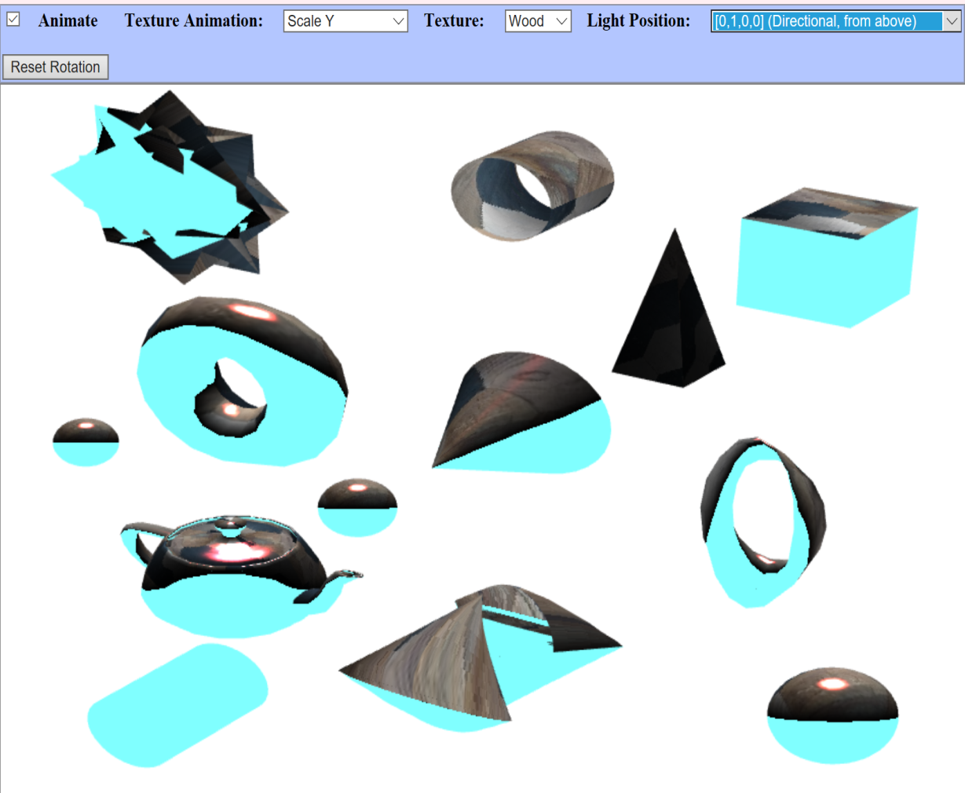

Figure 20: Light position = (0, 1, 0, 0)

* 1. [0,0,-10,1] (On z-axis, close to object): Direction of light is on z-axis and close to objects

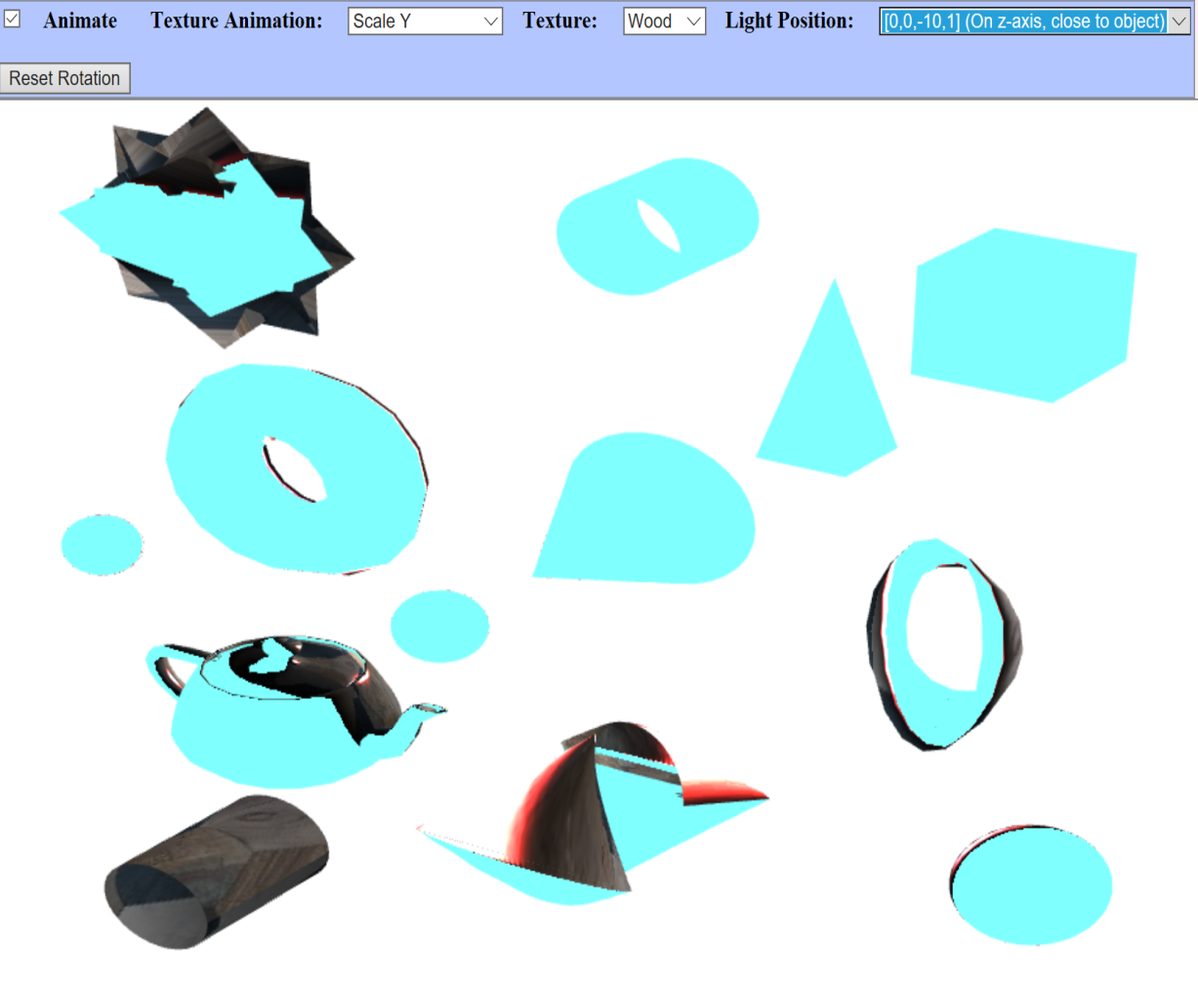

Figure 21: Light position = (0, 0, -10, 1)

* 1. [2,3,5,0] (Directional from upper right): Direction of light is from top-right position of canvas

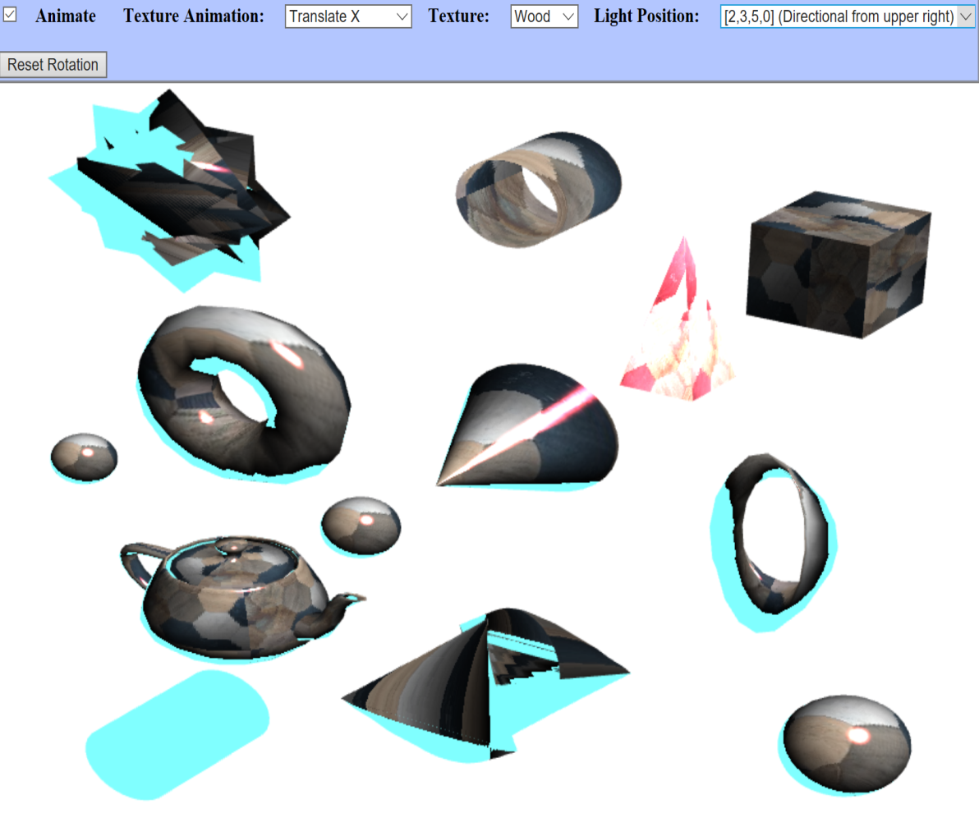

Figure 22: Light position = (2, 3, 5, 0)

* 1. Reset Rotation button removes rotated objects by mouse ( it resets their positions to the default). Also, texture animations are reset to their beginning points by using the reset rotation button.

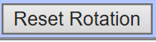

Figure 23: Reset button

* 1. Animate check box: 

Figure 24: Check box

The user can stop or start texture animation on objects by using the animate check box.

# **Test Plan**

|  |  |  |  |  |
| --- | --- | --- | --- | --- |
| Case | Input | Expected Output | Actual Output | Pass/Fail |
| 1 | Create **two** **torus** **shapes** in the right-middle and left-middle of the screen with two different sizes in x, and y | Created two torus shapes | Created two torus shapes | Pass |
| 2 | Create a torus shape in the left-top of the screen with **star** shape, change its size to be smaller | Created star-torus | Created star-torus | Pass |
| 3 | Create a torus shape in the middle-bottom of the screen with **bow** shape, change its size to be smaller | Created bow-torus | Created bow-torus | Pass |
| 4 | Create a **cube** shape in the top-right of the screen, change its size to be smaller | Created cube | Created cube | Pass |
| 5 | Create a **pyramid** shape in the top-right of the screen | Created pyramid | Created pyramid | Pass |
| 6 | Create **three spheres** shapes with three sizes in middle, right-bottom, and left-middle of the screen | Created three spheres | Created three spheres | Pass |
| 7 | Create **two cylinders** without lips in top and bottom in different height sizes. They are in top-middle and left-bottom of the screen | Created two cylinders | Created two cylinders | Pass |
| 8 | Create a **teapot** shape in left-bottom of the screen | Created teapot | Created teapot | Pass |
| 9 | Create a **cone** shape in in the z-axis, and with center at (0,0,0) | Created cone | Created cone | Pass |
| 10 | Create tire, fabric, marble, wood, and stone image **textures**  on objects | Created 5 textures | Created 5 textures | Pass |
| 11 | Create eight **texture animation** types of translate x, translate y, translate both of x & y, scale x, scale y, scale x & y, rotate, and rotate centered | Created eight texture animation types | Created eight texture animation types | Pass |
| 12 | Create five **light positions** of [0,0,0,1], [0,0,0,0], [0,1,0,0], [0,0,-10,1], [2,3,5,0] with default setting of diffuse Color = white,  specular Color = light red  main light color = cyan | Created five light positions | Created five light positions | Pass |
| 13 | Create an **animate check box** to control (stop/start) texture animation | Created animate check box | Created animate check box | Pass |

# **Screenshots:**

Screenshots of some of the test plan cases:

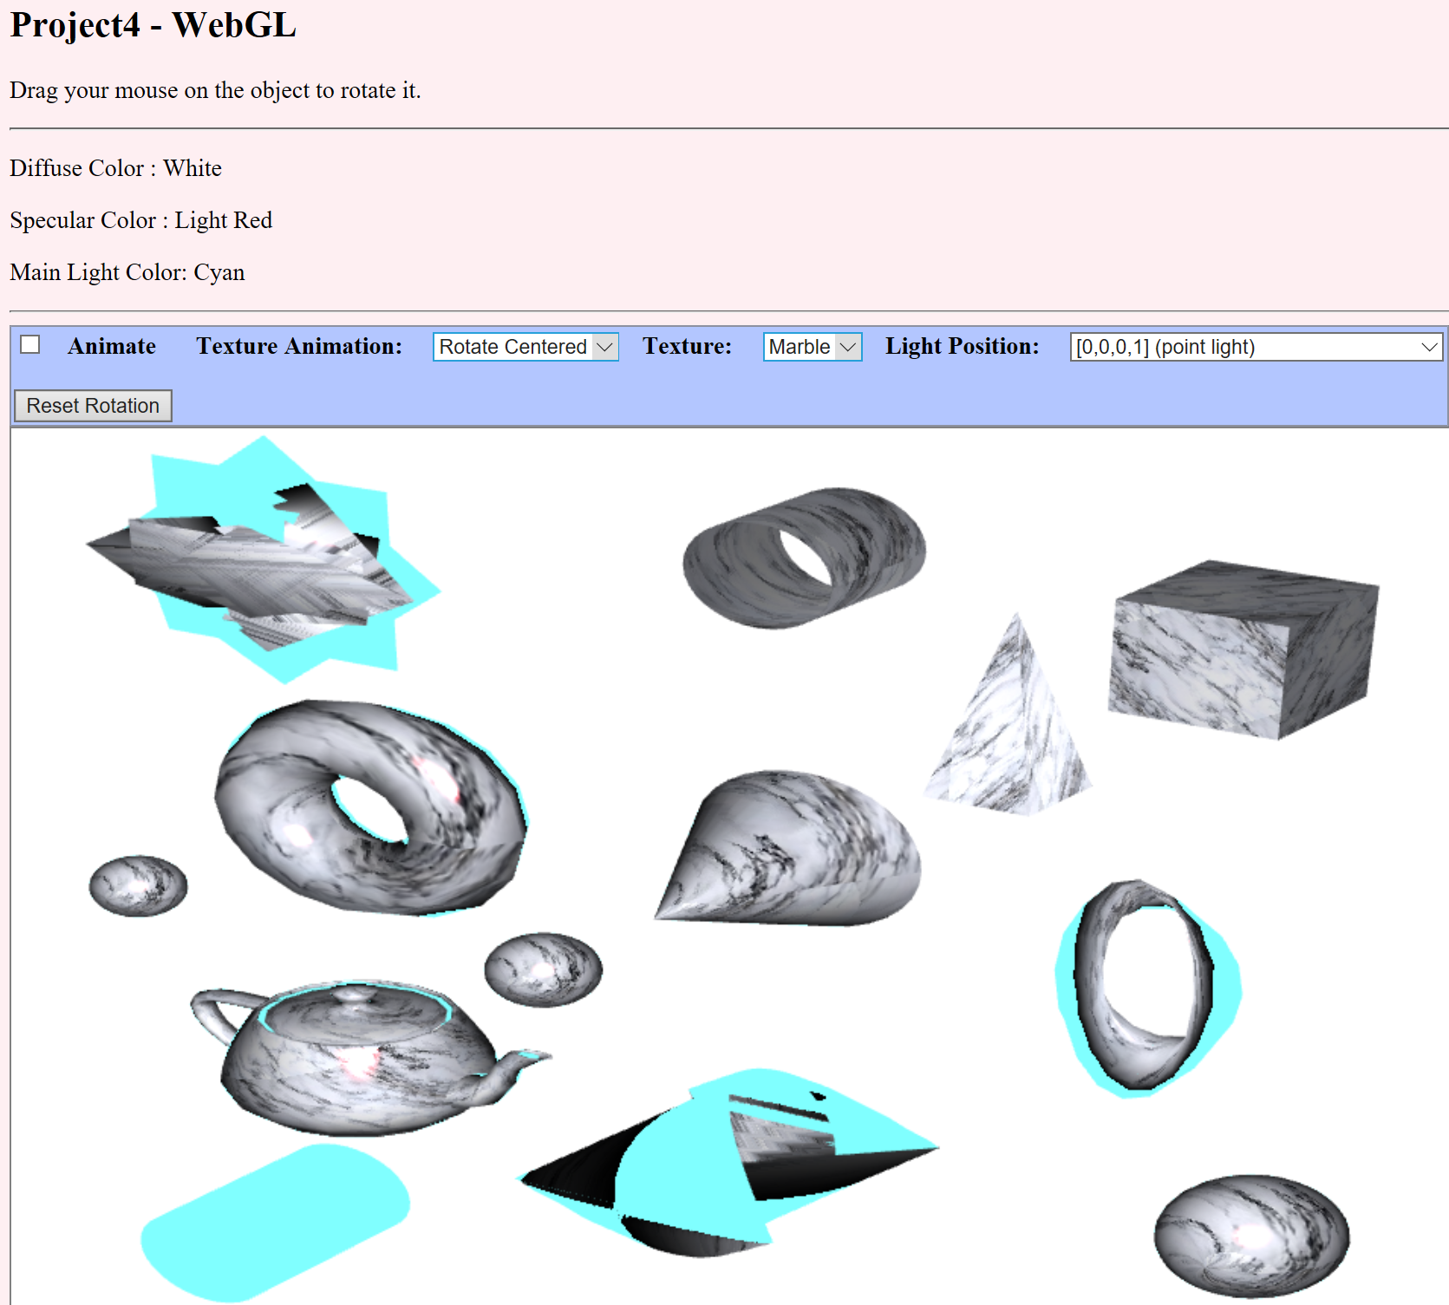

Figure 25: Screenshot 1

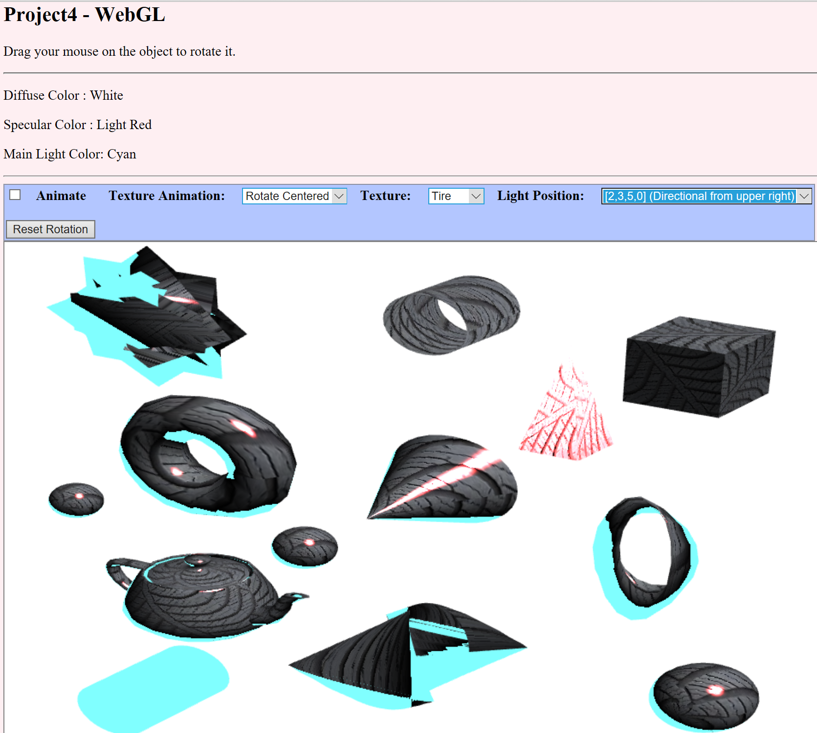

Figure 26: Screenshot 2

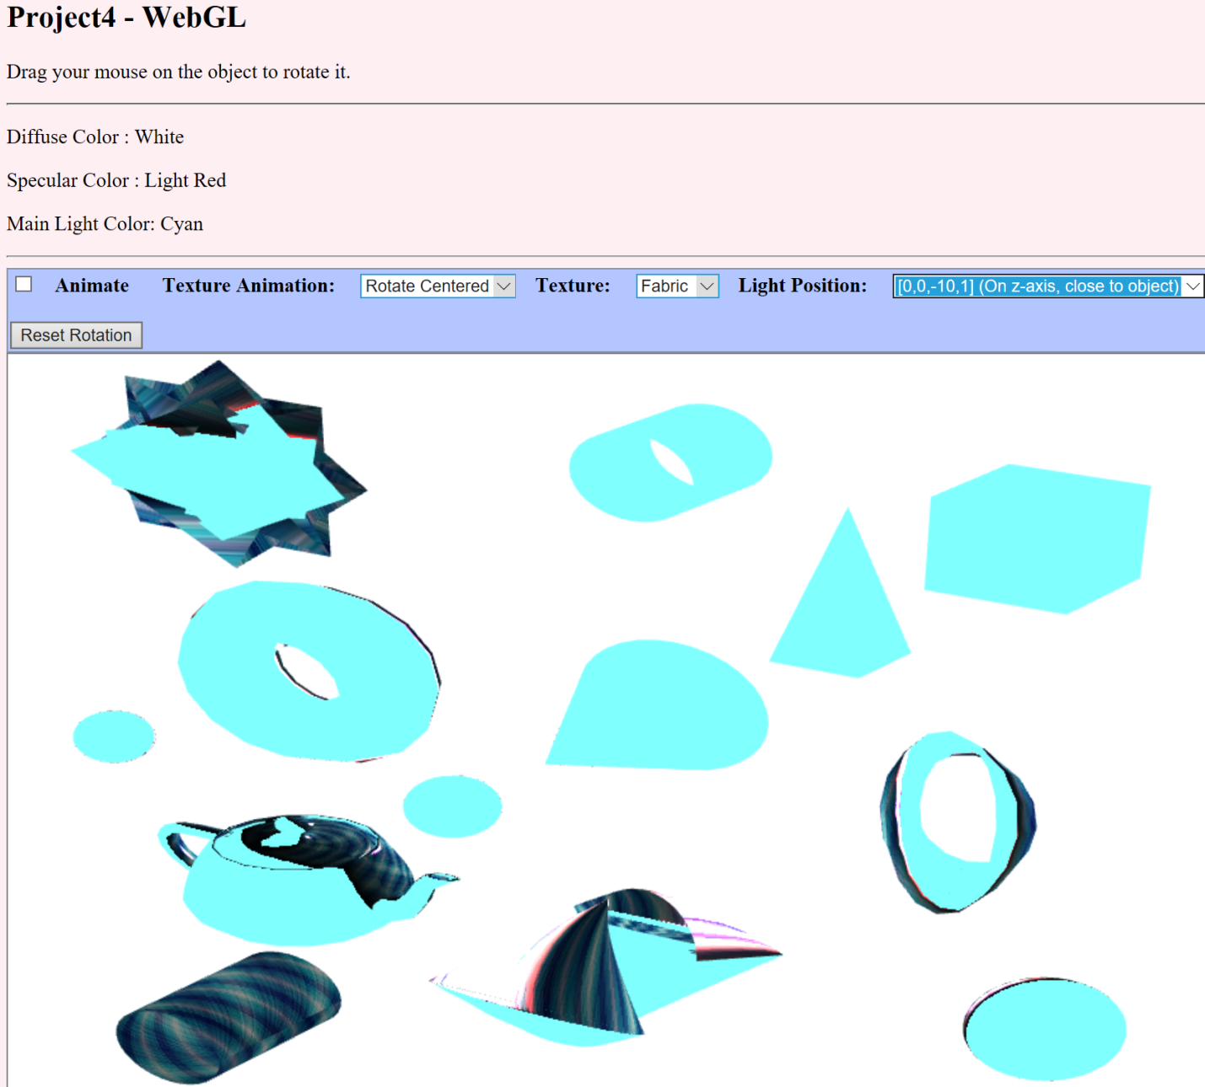

Figure 27: Screenshot 3

# **Lessons Learned**

* The WebGLBuffer interface represents a buffer object for storing data such as vertices or colors. Frame buffers are used to organize the memory resources that are needed to render the WebGL scene.
* The WebGLRenderingContext.createShader() method of the WebGL creates a WebGLShader that can then be configured further using WebGLRenderingContext.shaderSource() and compileShader().
* getUniformLocation() returns the location of a specific uniform variable which is part of a given WebGLProgram.

# **References:**

All modified references are placed as comments on their related codes in project4.html source file and basic-object-models-IFS.js in the project4 folder.

Original codes: basic-specular-lighting.html, texture-transform.html, trackball-rotator.js, gl-matrix-min.js, basic-object-models-IFS.js and teapot-model-IFS.js from webgl folder of CMSC 405 7982 Computer Graphics (2178) class.

WebGL 3D - Point Lighting: (WebGL 3D - Point Lighting)

WebGL 3D - Directional Lighting: (WebGL 3D - Directional Lighting)

Pyramid shape: (WebGL Lesson 4 – some real 3D objects)

WebGL 3D - Textures : (WebGL 3D - Textures)

Images which are used for textures:

Stone: (Stone-Image)

Wood: (Wood-Image)

Tire: (Free Seamless Rubber and Plastic Texture Patterns)

Marble: (fejjar)

Fabric: (Fabric-Image)

# References

*Fabric-Image*. (n.d.). Retrieved from www.photos-public-domain.com: http://www.photos-public-domain.com/wp-content/uploads/2011/01/blue-plaid-fabric-texture.jpg

fejjar, r. (n.d.). *Marble-Image*. Retrieved from weheartit.com: https://weheartit.com/entry/255044508

*Free Seamless Rubber and Plastic Texture Patterns*. (n.d.). Retrieved from www.cadhatch.com: http://www.cadhatch.com/seamless-rubber-and-plastic/4588167785

*Stone-Image*. (n.d.). Retrieved from i.pinimg.com: https://i.pinimg.com/originals/93/fc/f8/93fcf866aee97c79fb58c36c88e08394.jpg

*WebGL 3D - Directional Lighting*. (n.d.). Retrieved from webglfundamentals.org: https://webglfundamentals.org/webgl/lessons/webgl-3d-lighting-directional.html

*WebGL 3D - Point Lighting*. (n.d.). Retrieved from webglfundamentals.org: https://webglfundamentals.org/webgl/lessons/webgl-3d-lighting-point.html

*WebGL 3D - Textures*. (n.d.). Retrieved from webglfundamentals.org: https://webglfundamentals.org/webgl/lessons/webgl-3d-textures.html

*WebGL Lesson 4 – some real 3D objects*. (n.d.). Retrieved from learningwebgl.com: http://learningwebgl.com/blog/?p=370

*Wood-Image*. (n.d.). Retrieved from www.archiproducts.com: http://www.archiproducts.com/en/products/idee-parquet/english-oak-parquet-azulejo_275613